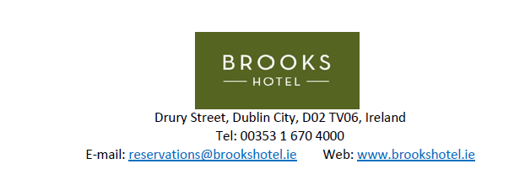
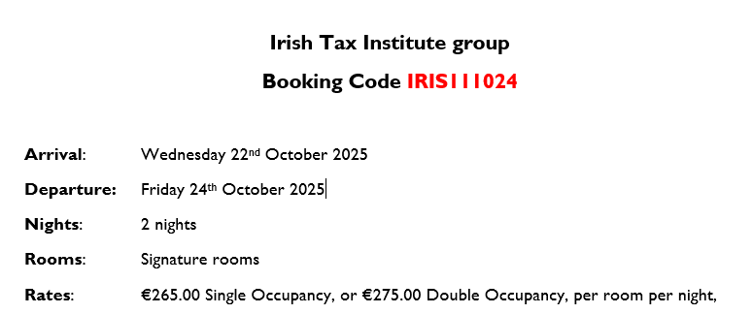

Booking request details
- Guest Name and Surname _____________________________________________________
- Arrival date ____________
- Departure date ___________
- Number of guests ______________
- Guest e mail address ____________________________________________________________
- Special requests ____________________________________________________

Terms and Conditions:
- Guests to email this form filled to reservations@brookshotel.ie
- Pre-payment requested upon booking – a secure payment link will be sent via e mail to each guest
- The payment is to be processed within 48 hours, after that the bookings without payment will be cancelled.
- Each booking can be cancelled free of charge until 21 days before arrival. 100% cancellation fee applies after 21 days.

